In AWS EC2 Concole , left side you will see Network & Security tab , click that you will get options like this

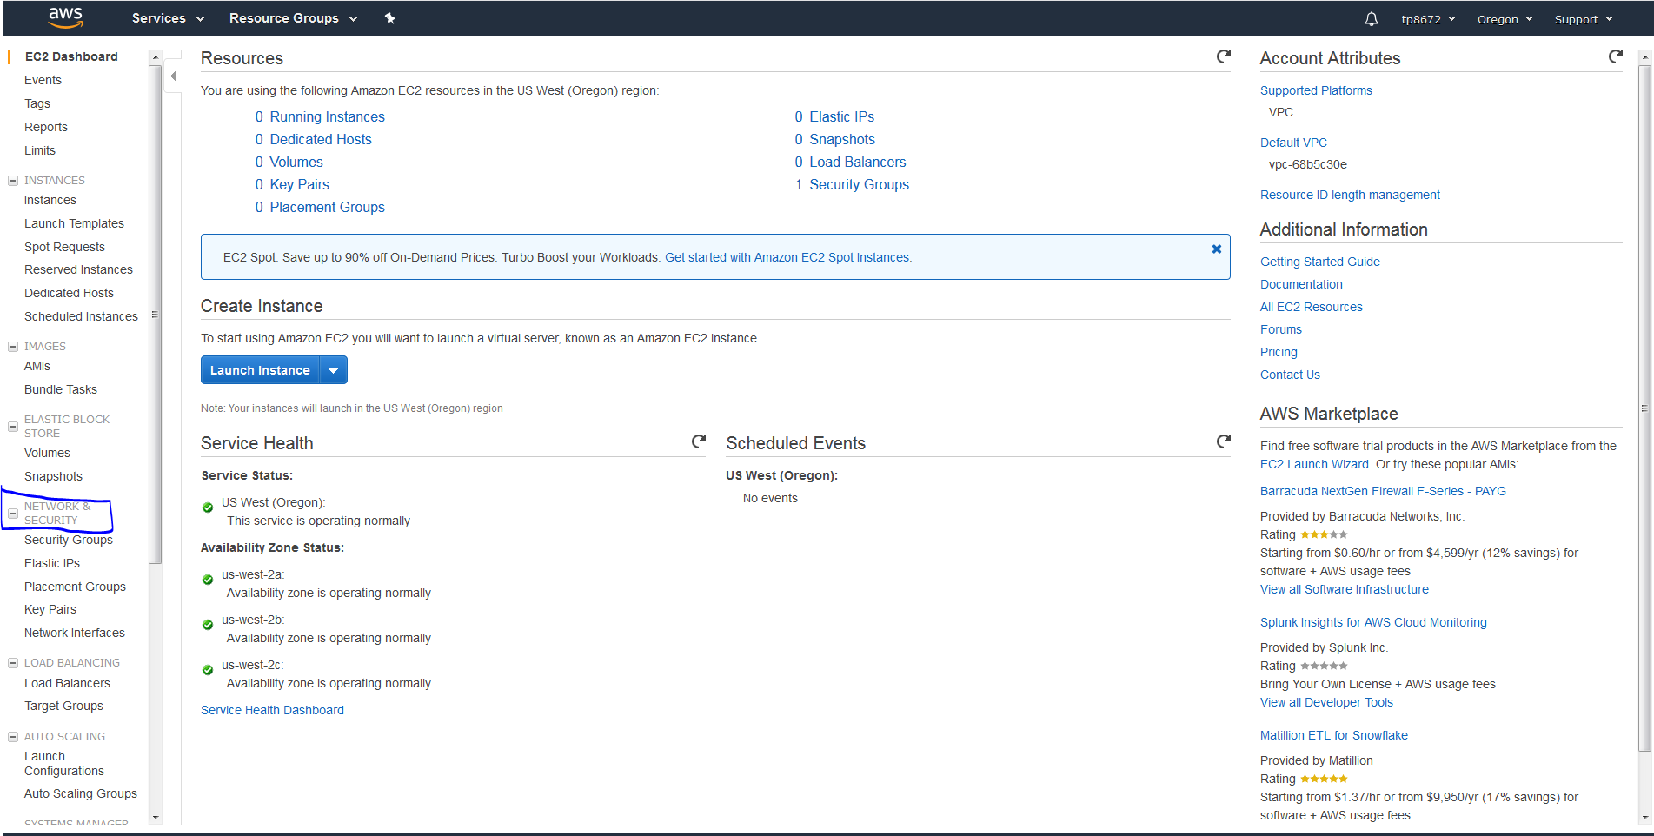

Click Security Group as show below

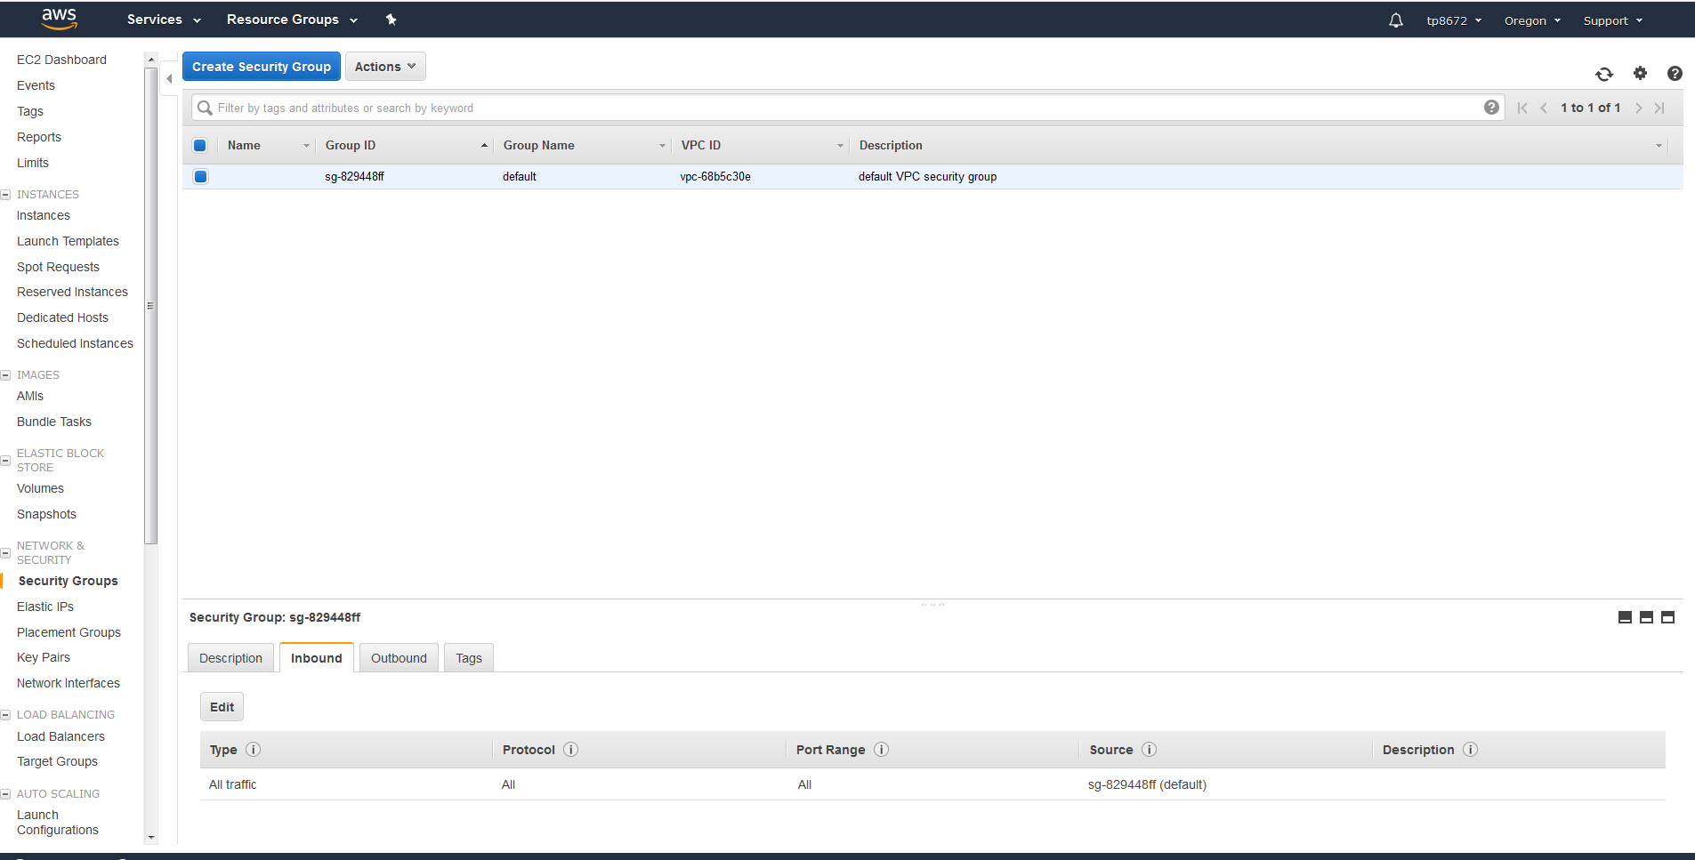

In Security Groups --- > you can see bottom Security Group as sg-29448ff , under that you can find tabs such as **Description , Inbound , Oubound and Tags**

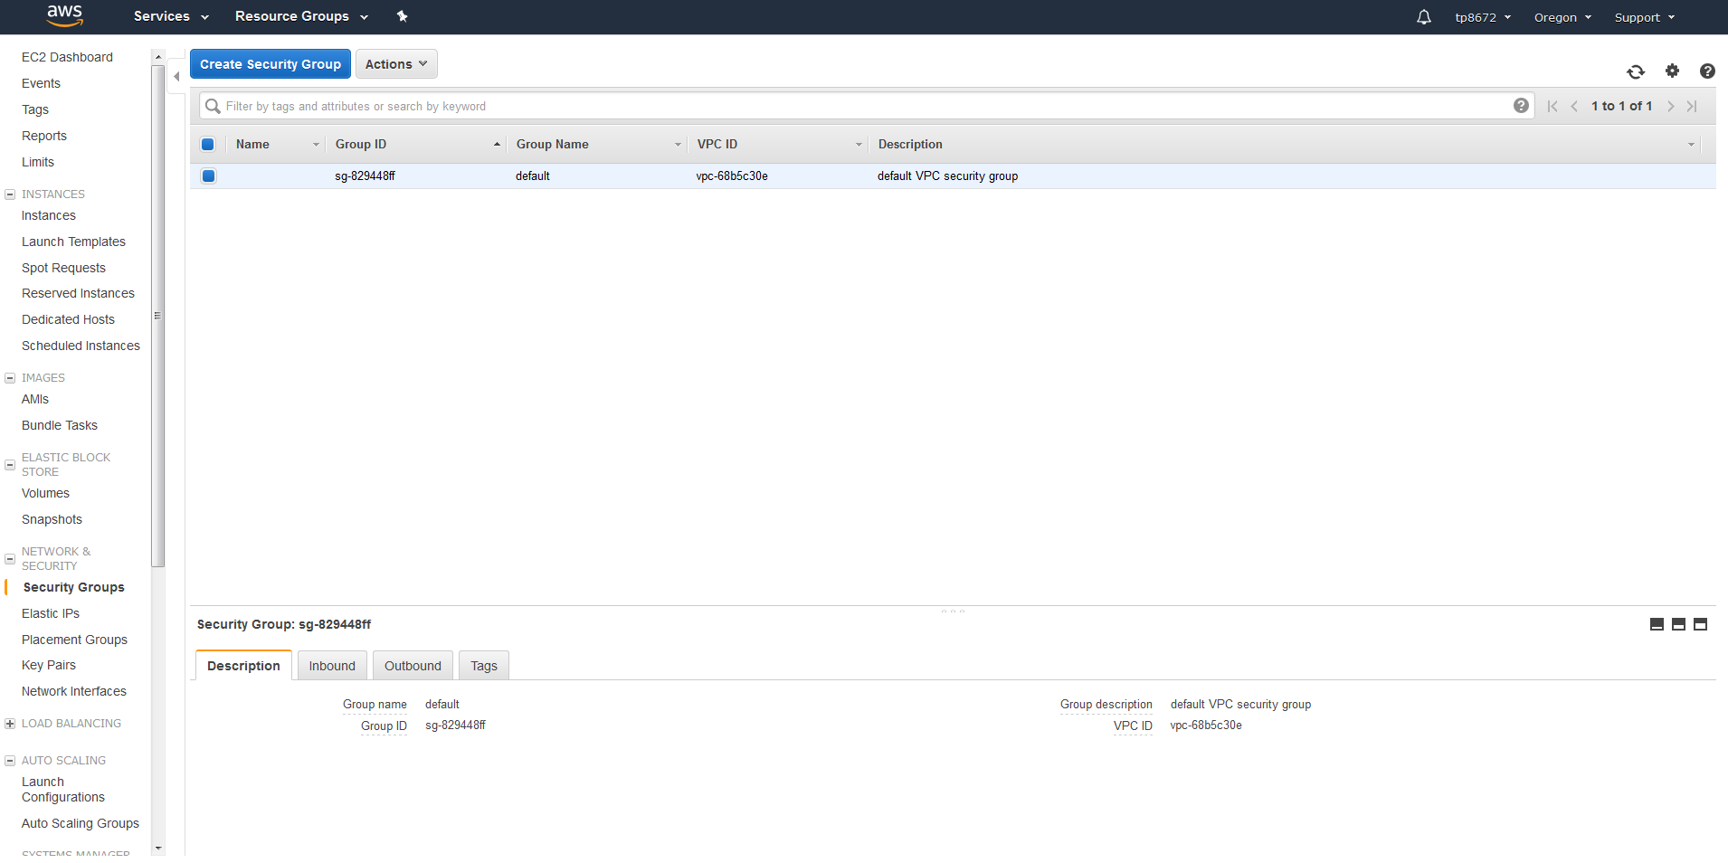

Click Inbound and you get EDIT option and click Edit you will see the screen like below

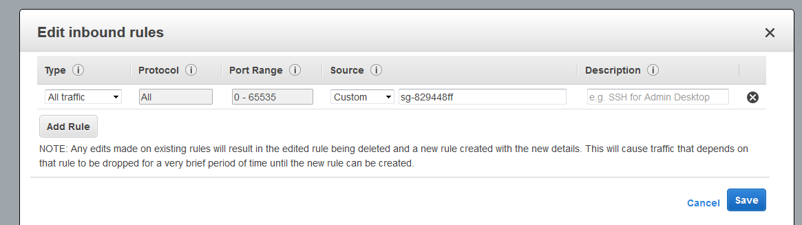

Now click ADD RULE button and add

You will get options like

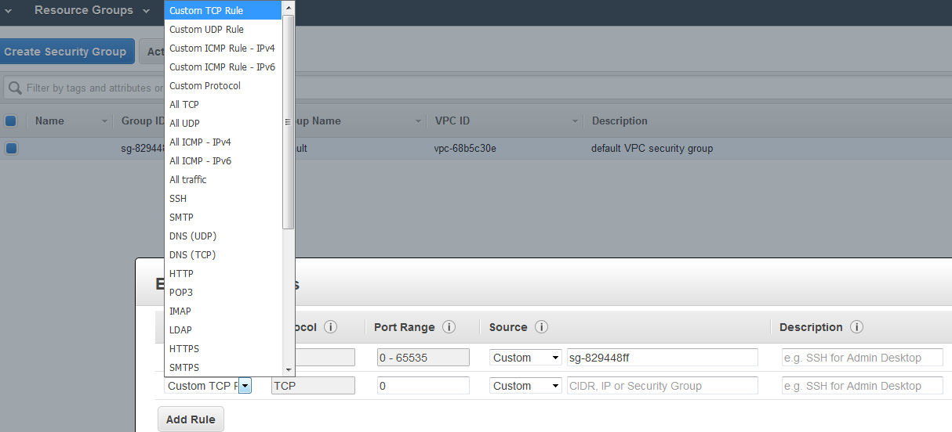

As an example, if you are configuring an EC2 instance to be a Web server, you’ll need to allow the HTTP and HTTPS protocols.  When you select them from the list, and the security group would be altered as shown below.

Mention Port Range , Source as Custom to add different IP and then mention IP address and then mention description as below

For example:

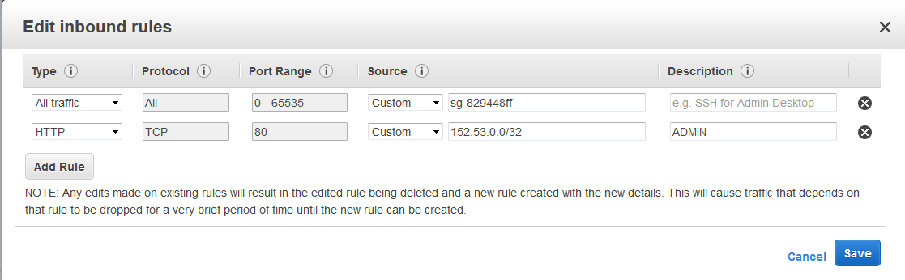

After adding click save button , like that you can add many IP address/ mention Range of IP address along with CIDR